Xpert Pro Features > Admin Login:
Admin can enable or disable pro feature for particular company. Company user can access pro features if this checkbox is enabled.
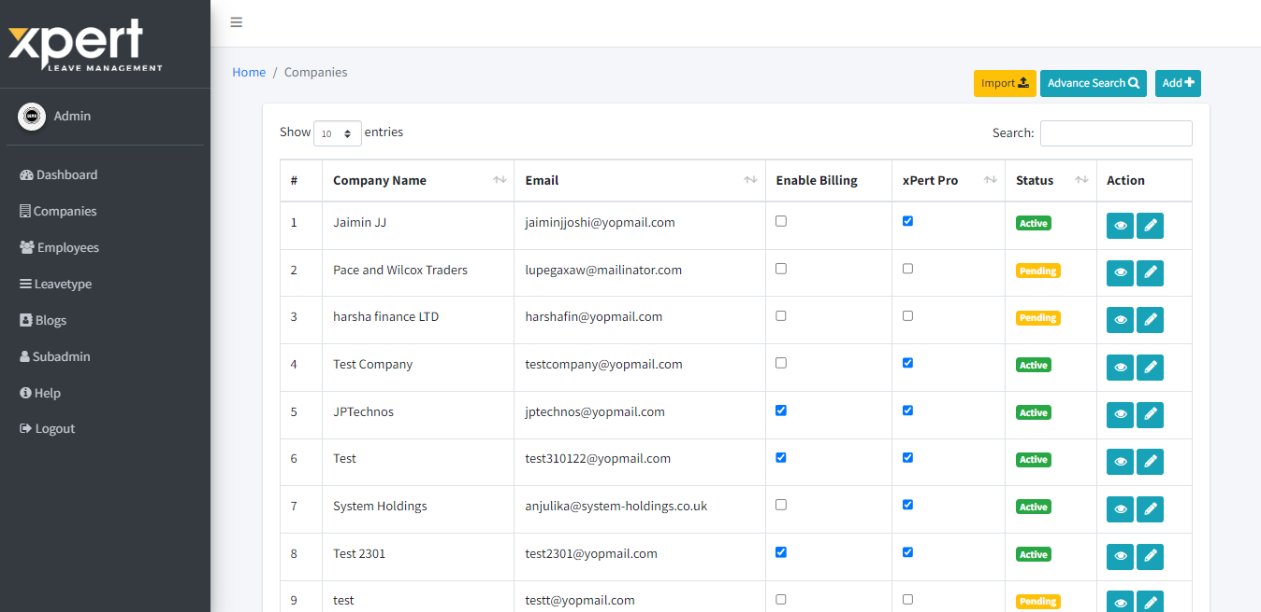
Xpert Pro Features > Company Login:
Register > Step 2:
You can add particular user counts in “No of user” field. You will be able to create maximum number of employees/managers which you have added here.
On “Enable Xpert Pro” checkbox selection, it will count as xpert pro account. On “I” icon hover, you can see features of Xpert Pro.
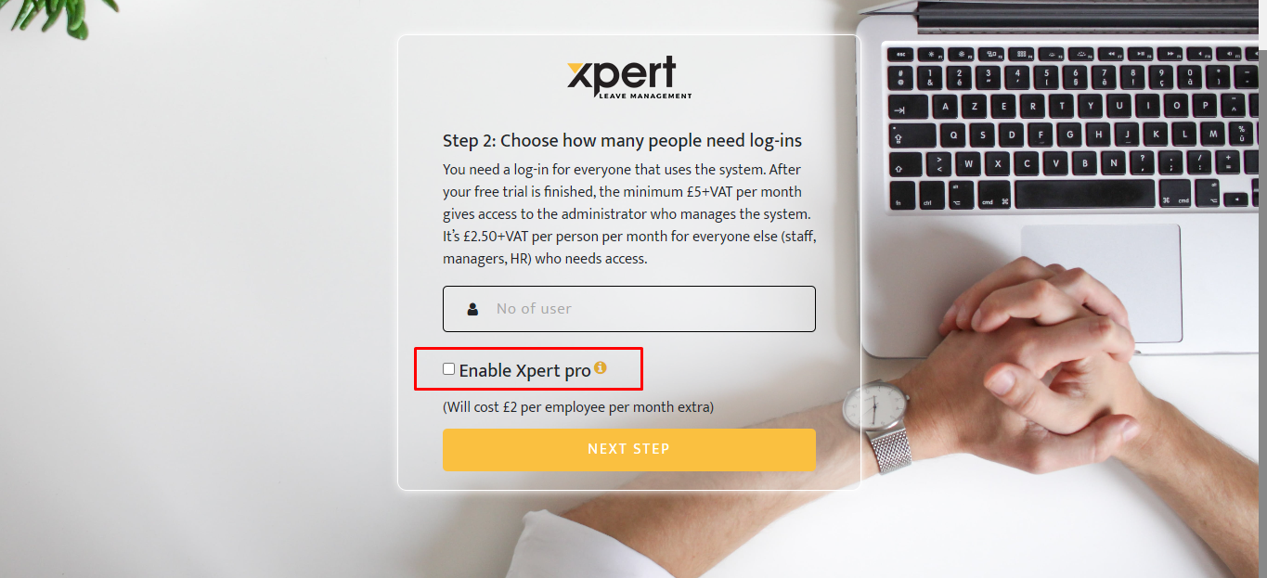

Dashboard:
You can see extra features in side menu when logged in with Xpert Pro Account.
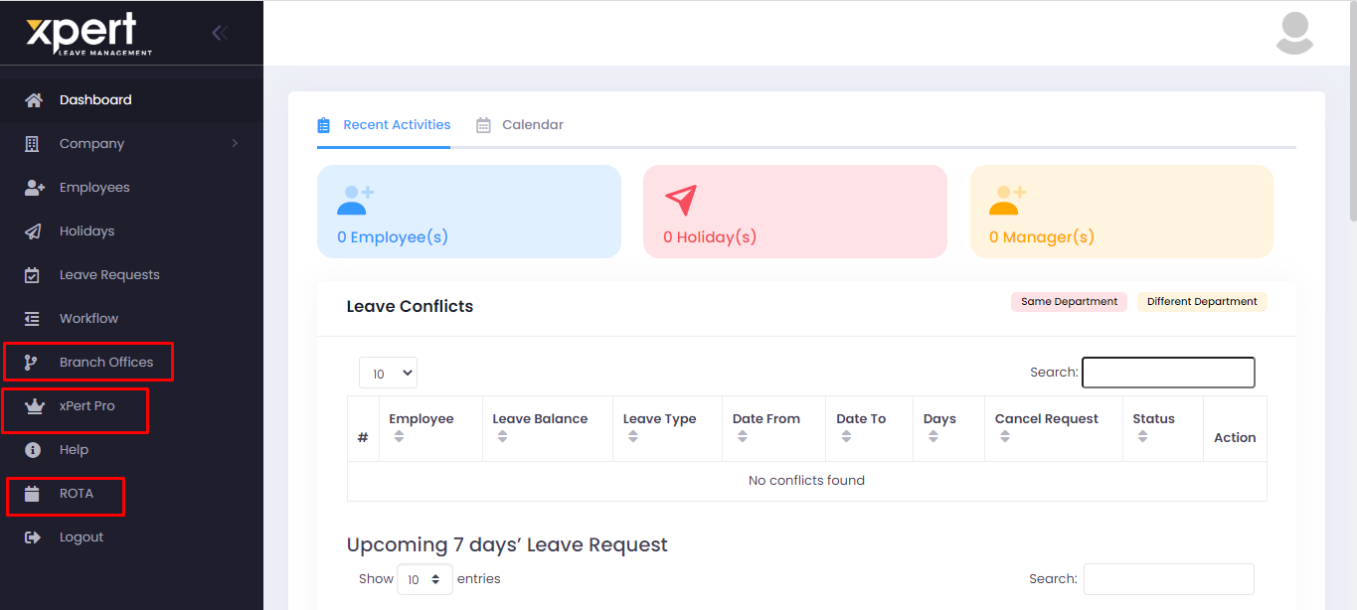

Xpert Pro popup:
It will open xpert pro feature related popup when you select “Xpert Pro” from side menu. If you do toggle Off, it will convert in to normal xpert feature & pro features will remove from the account.
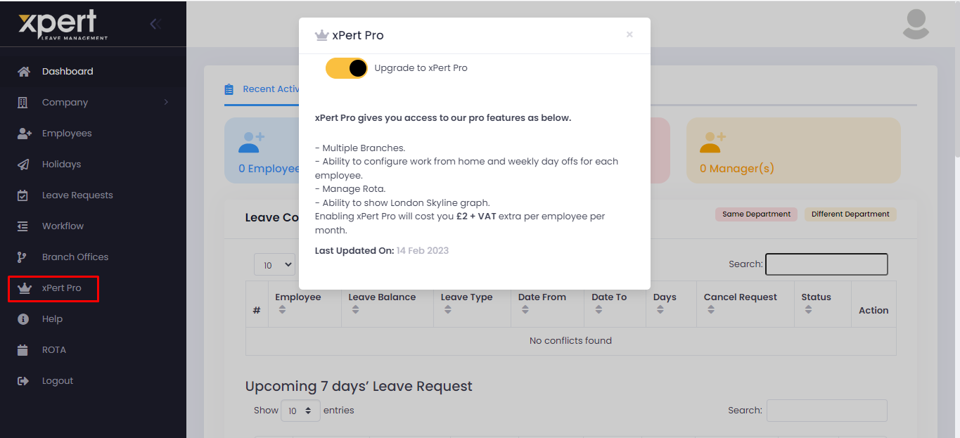

London Skype Graph:
You can review particular details from London skype graph. You can view details branch wise and date range wise too.

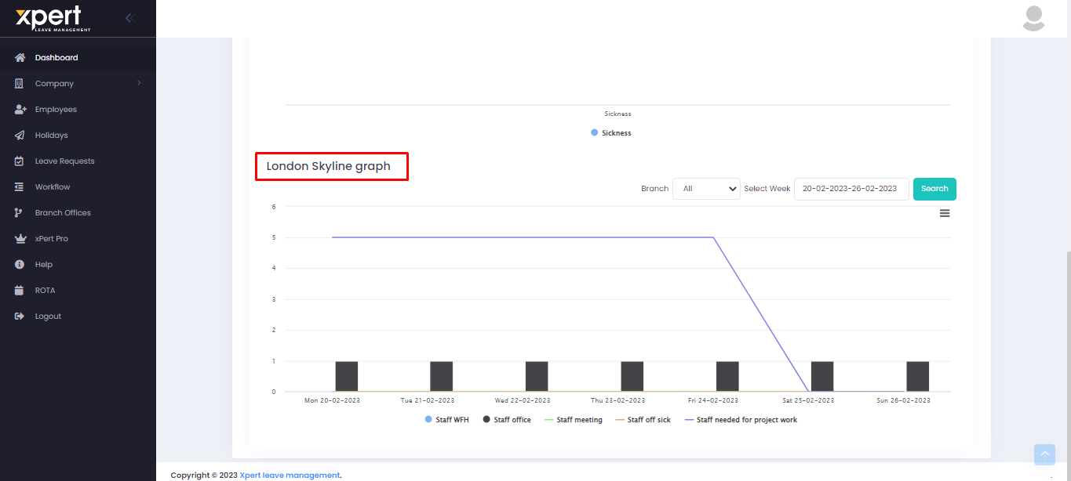

Branch Offices:
You can link your employees/managers branch wise by creating branches from here. You can add new branch from “Add Branch” button selection. Newly created branches will show in listings here. You can edit/delete branch from action column.
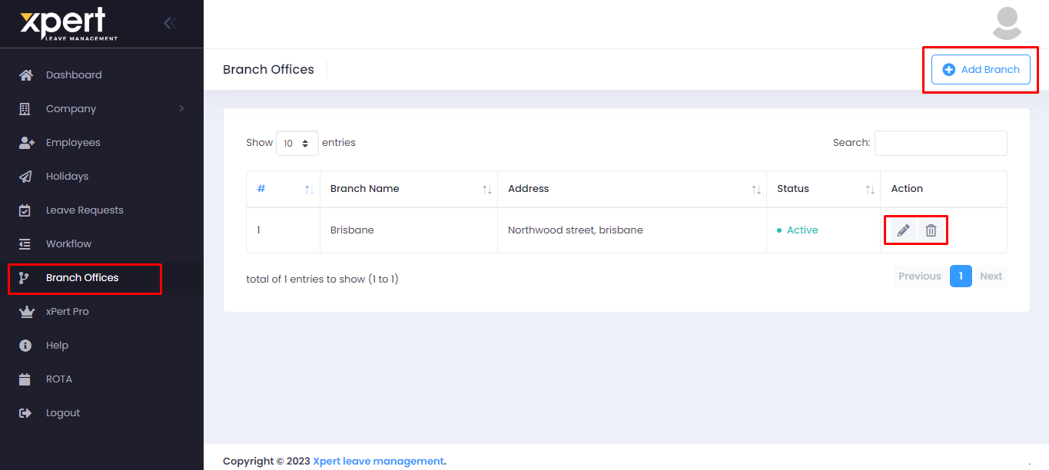
Add Branch:
You can add Branch name & branch address in add branch popup.
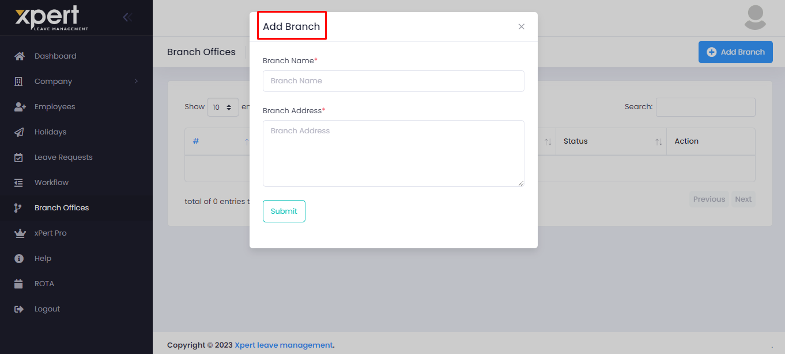

Add Shift:
You can see “Branch” & “Min. Number of Staff Required” fields in add/edit shift popup when it is pro account. In branch field, you can select particular branch which you have created in branch offices module. In “Min. Number of Staff Required” field, you can add particular number of count whichever you want to add for created shift.
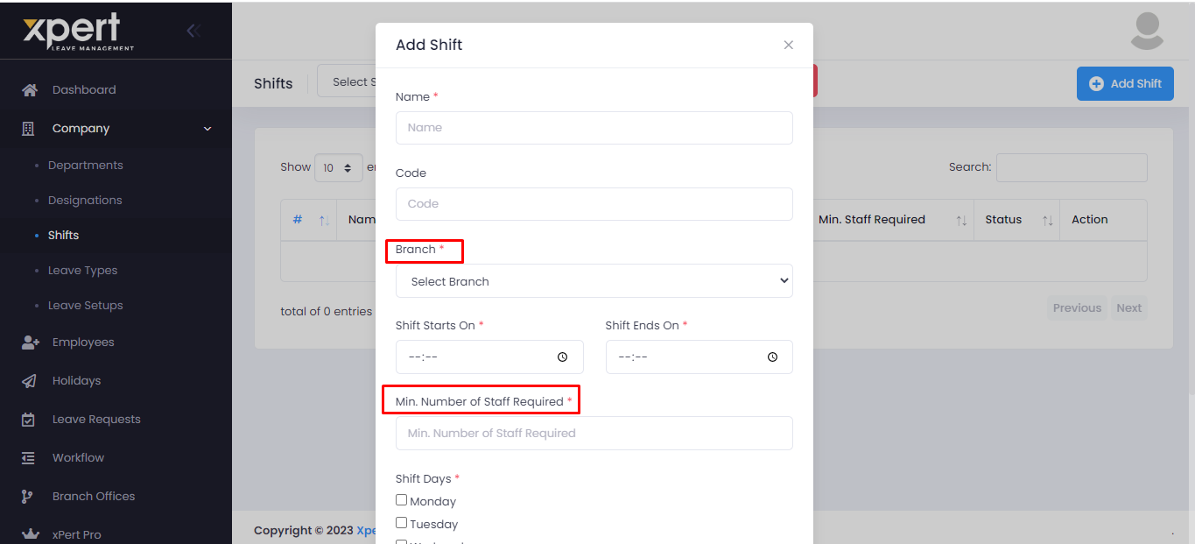

Add Employee/Manager:
You can see branch field when create particular employee/manager. Reporting manager list will show according to branch selection.
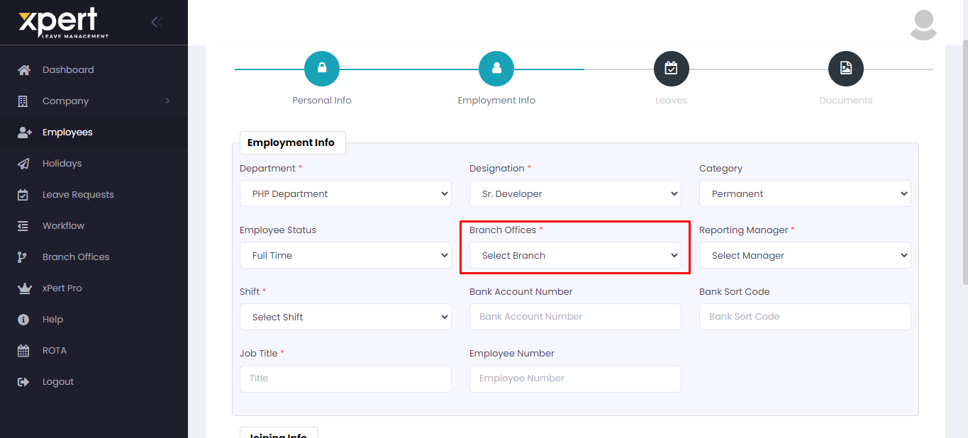

View Employee/Manager:
Work From Home:
In particular employee/manager’s view page, you can see “Work From Home” feature. By default checkbox will show unselected.
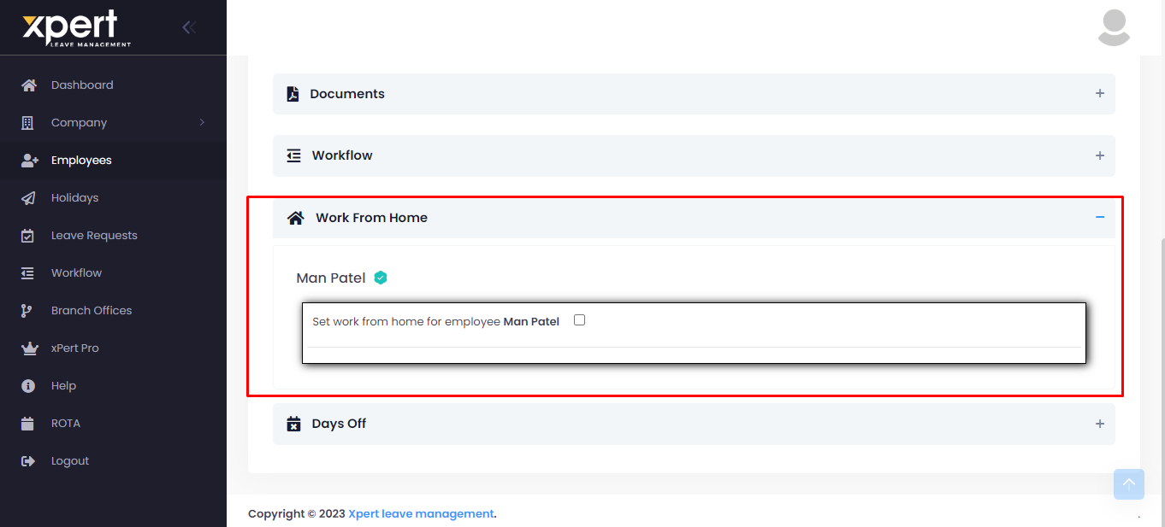

On checkbox selection, it will show From & To date fields to select particular date range for work from home. Furthermore, you can select specific days for work from home by selecting “Select Specific Days For The Work From Home” checkbox.
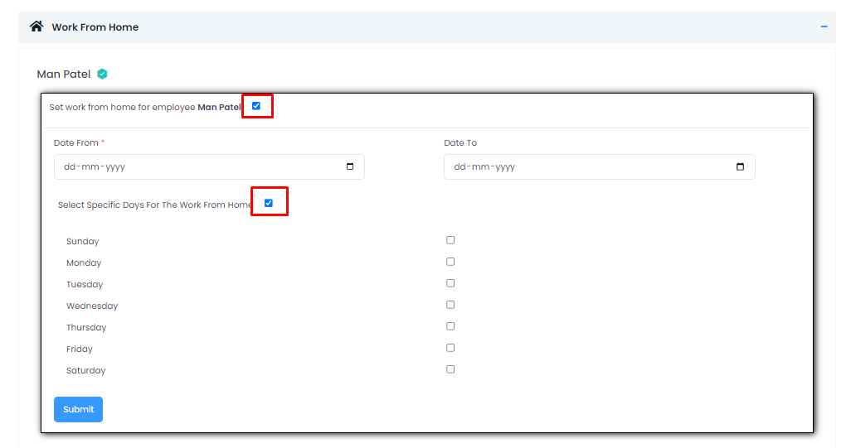

After getting saved, it will show data in “Work From Home” section. You can edit details by selecting “Edit” button. Furthermore, same will show in particular employee/manager’s my profile page.
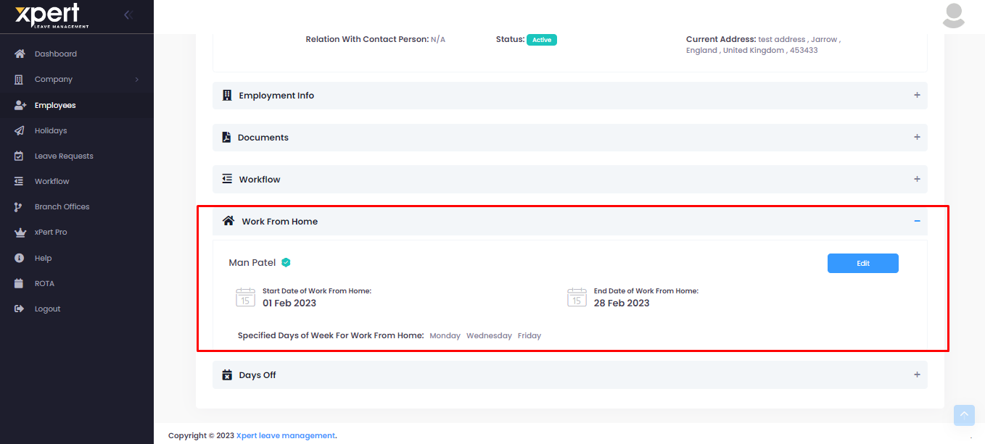

Days Off:
You can set particular employees’ days off from here. You can add days off by selecting “Add” button.
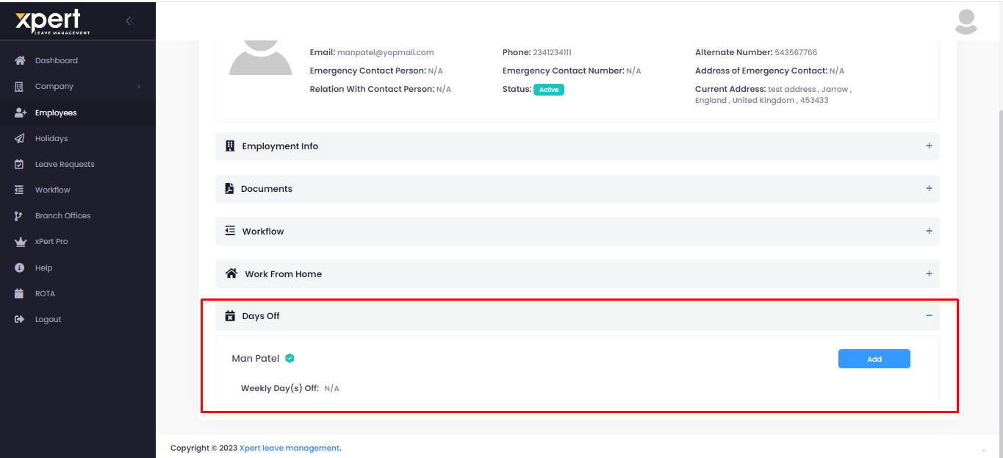

On Add button selection, you can see particular days with checkboxes to select. You can select particular day’s checkbox. Your selected days will count as weekly day(s) off.
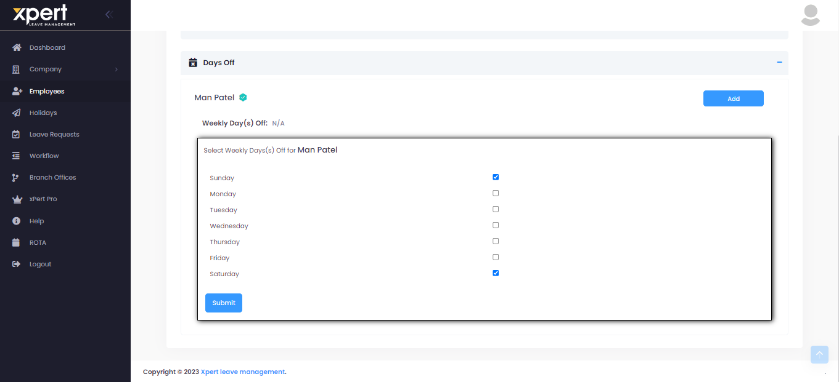

After getting saved, you can see added details in “Days Off” section. You can edit details by selecting “Edit” button. Same will show in particular employee/manager’s my profile page.
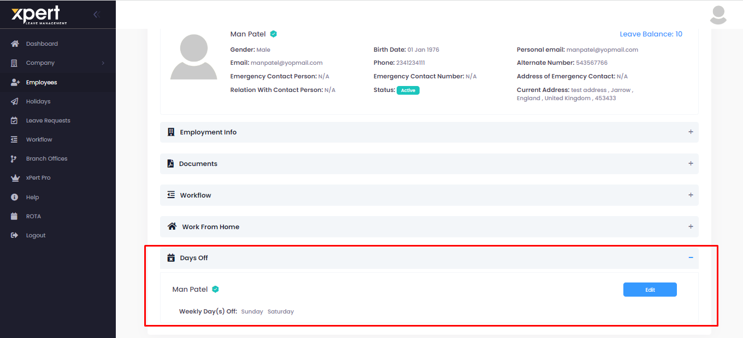

ROTA:
ROTA is used to create shift wise employee list. By default, it will show blank listings. You can select particular shift from “Select Shift” dropdown.
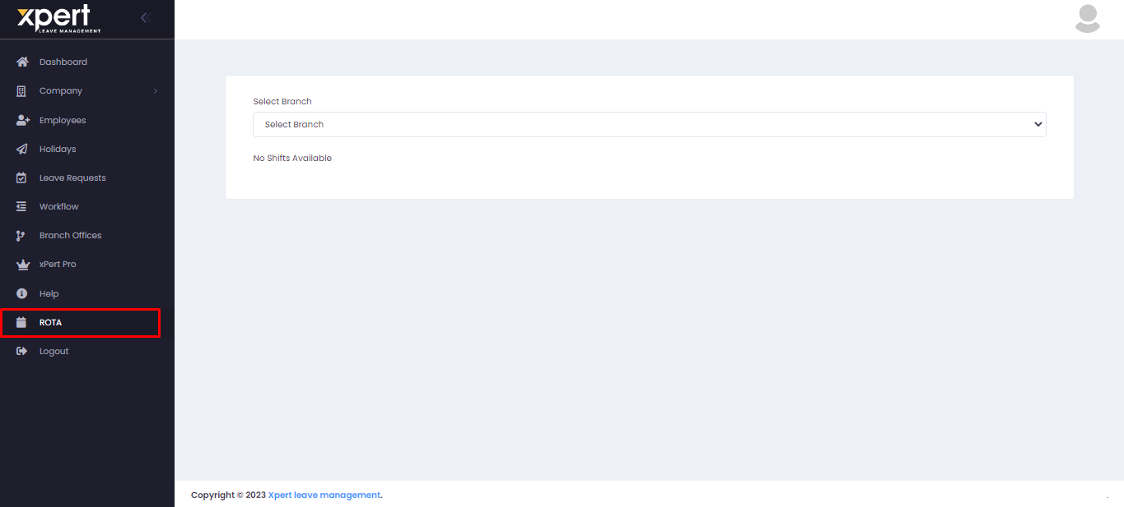

Based on particular shift selection, it will show data. If you haven’t linked shift with branch, then it will not show data here. By default, it will show current week’s data. You can go to next weeks by selecting “Next” button.
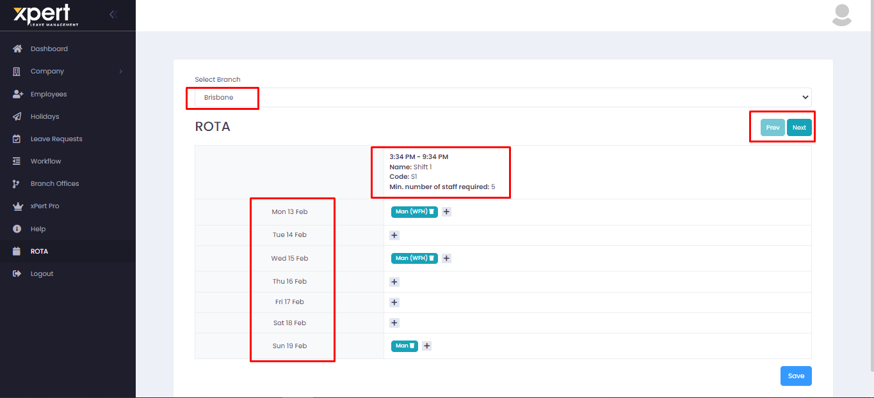

You can add particular employee in ROTA by selecting “+” button. It will open side bar to select particular employees. It will show only employees’ listings which were linked with that shift. From side bar, you can select “+” button to add that employee in ROTA. If particular employee has day off on that day, then it will show “Is on Leave Today” label below date in side bar.
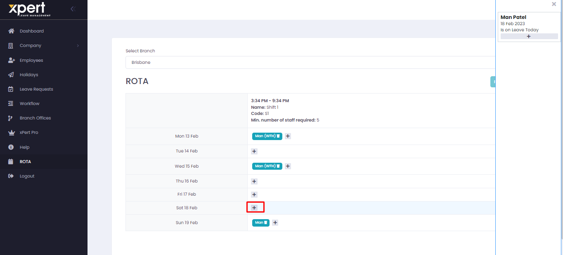

Manager Login:

Dashboard:
You can see extra features in side menu when logged in with Xpert Pro Account.
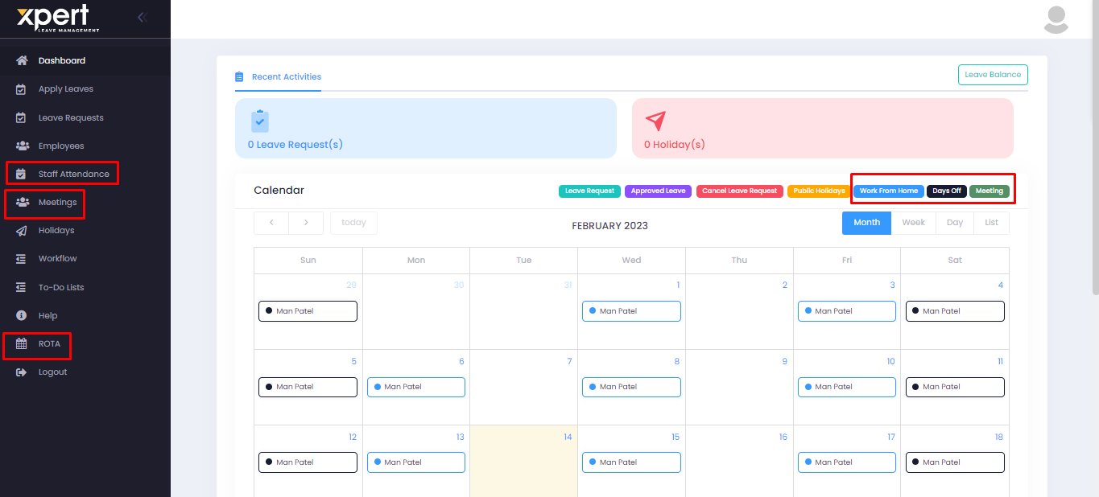

Recent Activity (Xpert Pro)
Here you can view work from home, days-off and meetings events in calendar.
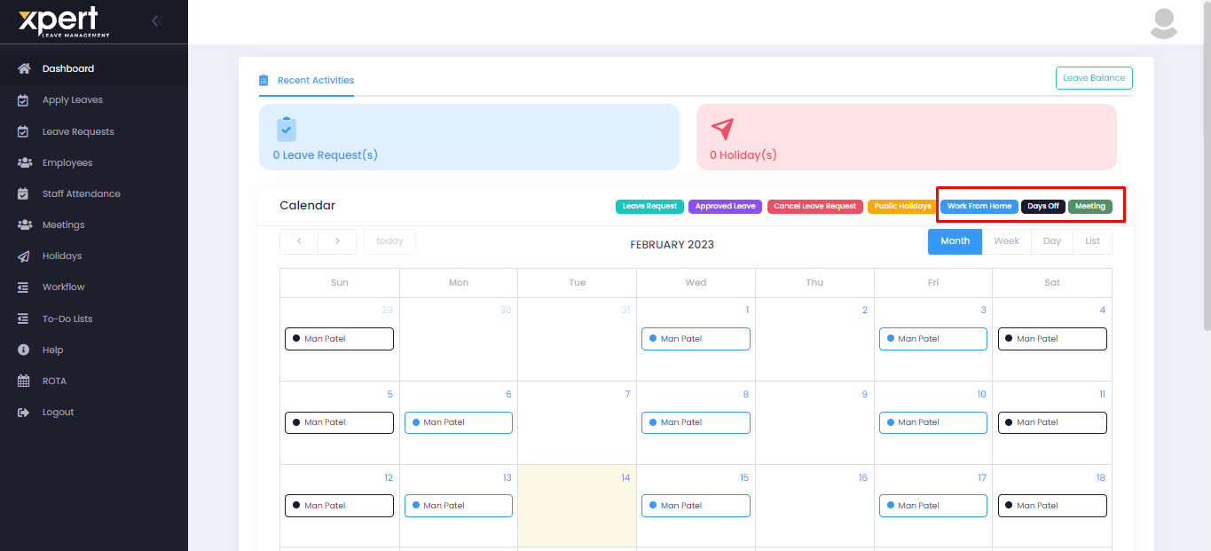

View Profile (Xpert Pro)
If it has a pro account, then Employee can view Work from Home, Branch Office and Days off in their profile.
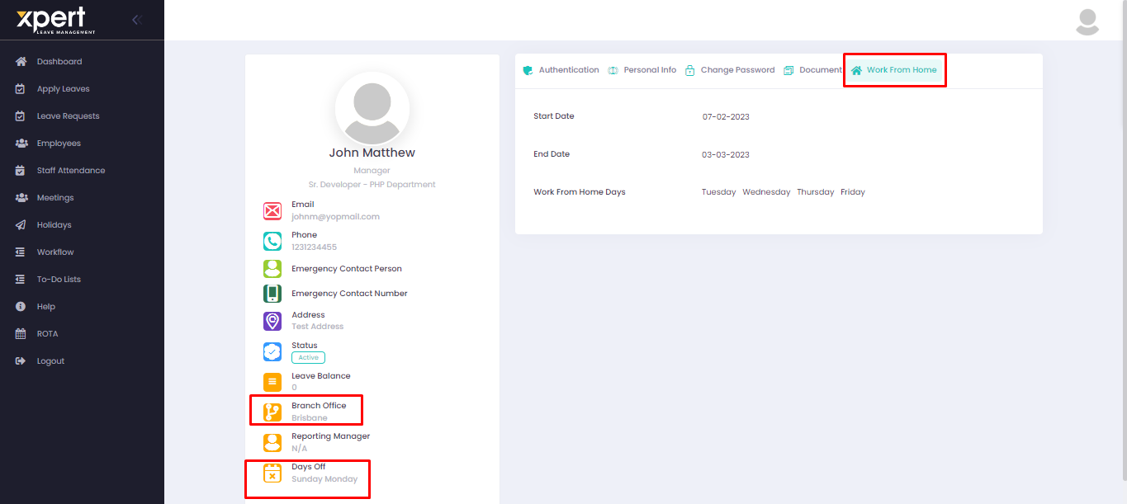
View Employee/Manager:
Work From Home:
You can view particular employees’ work from home from view page.
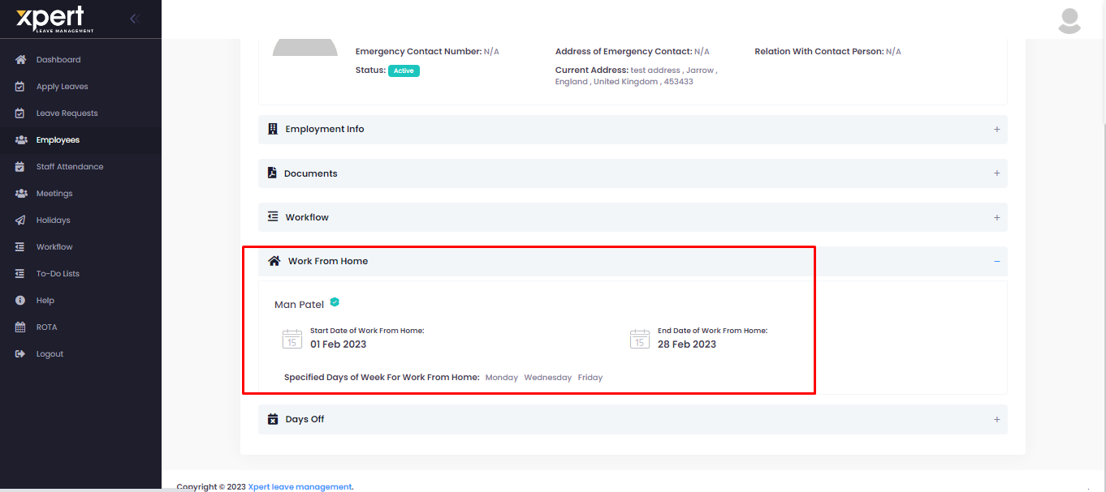

Days Off:
You can view particular employees’ Days off from view page.
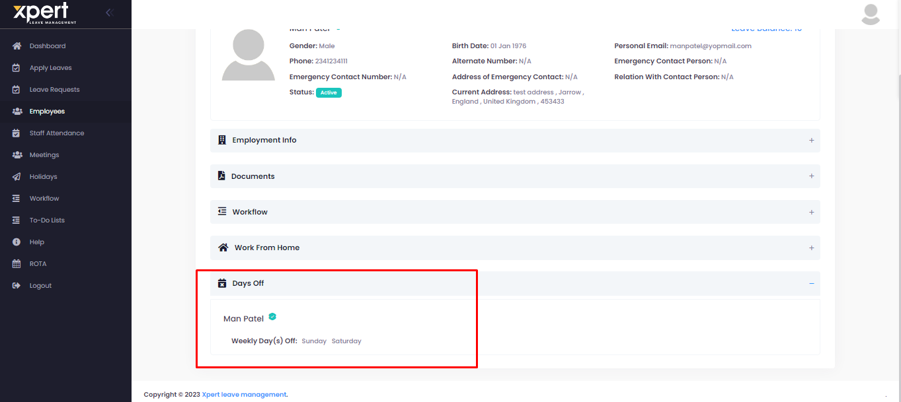

ROTA:
ROTA is used to create shift wise employee list. By default, it will show blank listings. It will show only that shifts which is linked with manager’s branch.
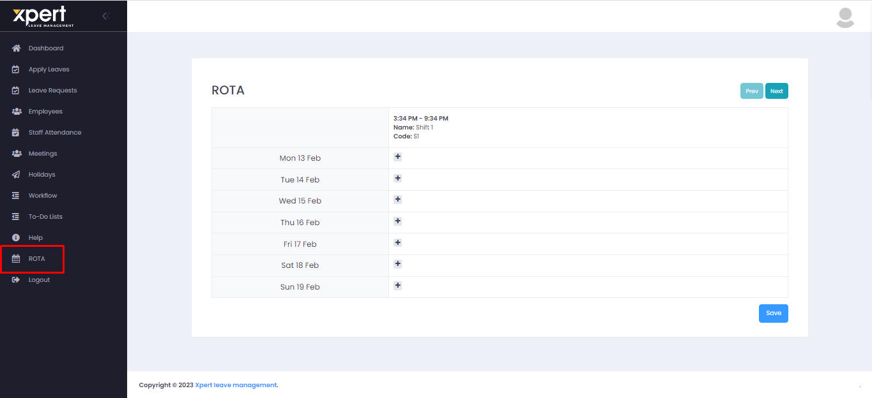

Based on particular shift selection, it will show data. If you haven’t linked shift with branch, then it will not show data here. By default, it will show current week’s data. You can go to next weeks by selecting “Next” button.
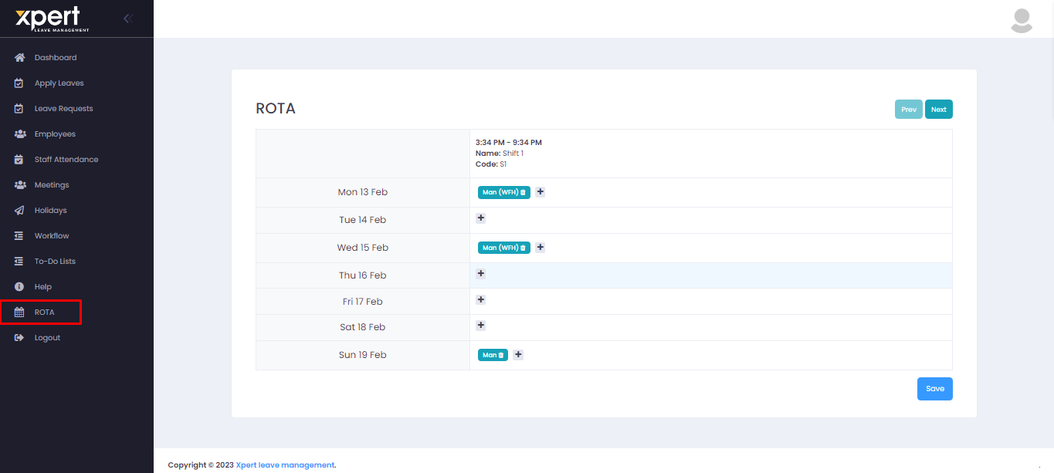

You can add particular employee in ROTA by selecting “+” button. It will open side bar to select particular employees. It will show only employees’ listings which were linked with that shift. From side bar, you can select “+” button to add that employee in ROTA. If particular employee has day off on that day, then it will show “Is on Leave Today” label below date in side bar.
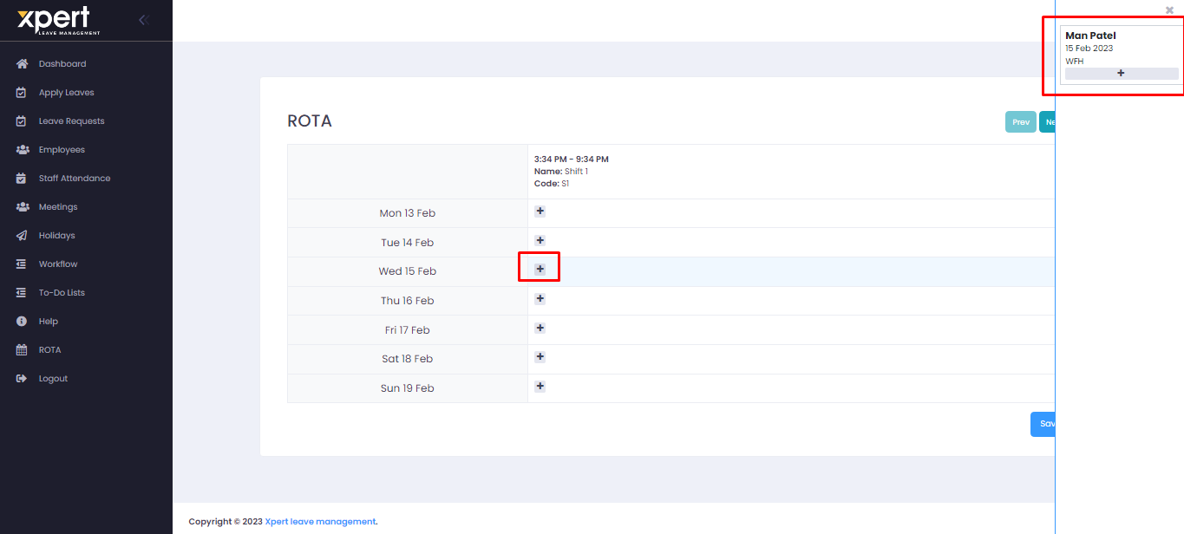

Staff Attendance:
You can view particular staff’s attendance related details from here. You can add attendance by selecting “Add Staff Attendance” button. Furthermore, you can edit/delete particular records from action column.
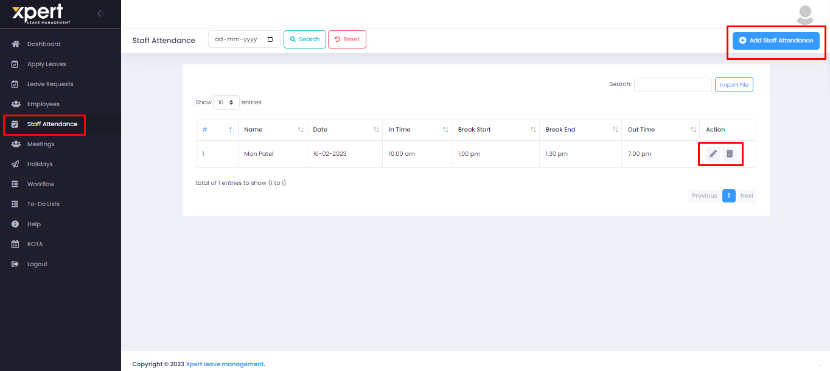

On Add Staff Attendance button selection, it will open “Add Staff Attendance” popup. It will show list of employees who linked with this manager. Besides particular employee’s name, it will show checkbox to select. On checkbox selection, it will show field to enter time. After saving record, it will show in listings.
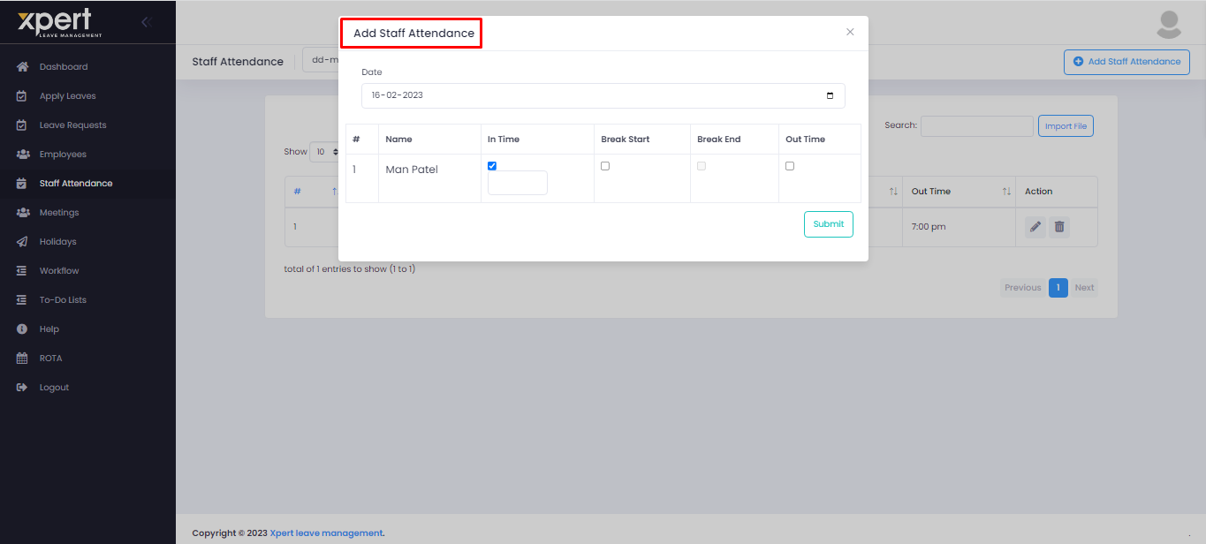

Import Staff Attendance:
Instead of entering staff attendance manually, you can import file in listings directly by selecting Import file button. On button selection, it will open popup where you can upload file & submit. For exact format, you can download file from “Download Format” link selection.
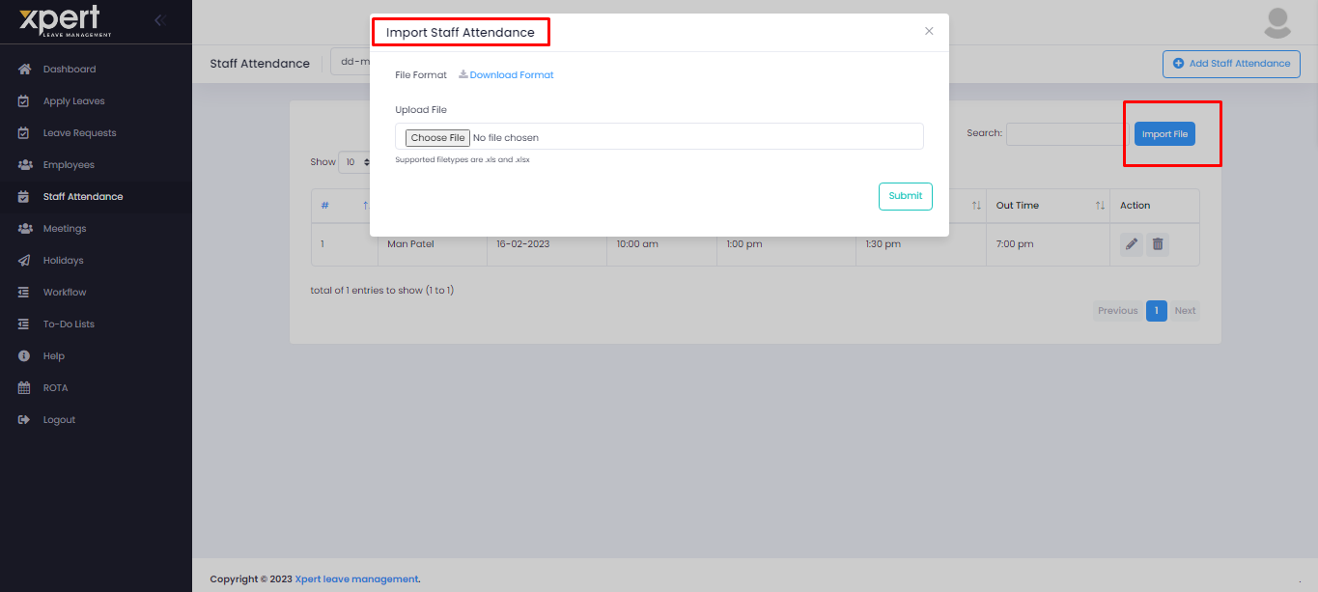

Meetings:
You can add meetings from here. Added meetings will show in listings. You can add new meeting by selecting “Add Meeting” button. You can edit/delete/view particular meetings by selecting relevant buttons from action column. In listings, it will show future meetings only. Once you add meeting, it will show in manager & selected employees’ calendar.
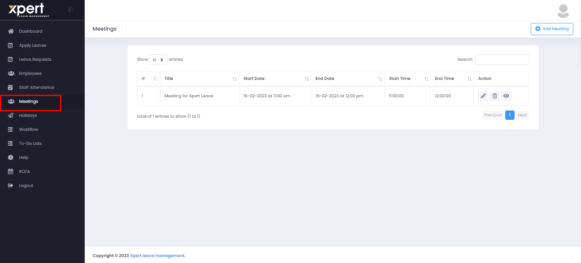

Add Meeting:
On Add meeting button selection, it will open popup. you need to fill up all mandatory fields. In “Employees” field selection, it will show list of employees. You can select particular employee to whom you want to invite for meeting.
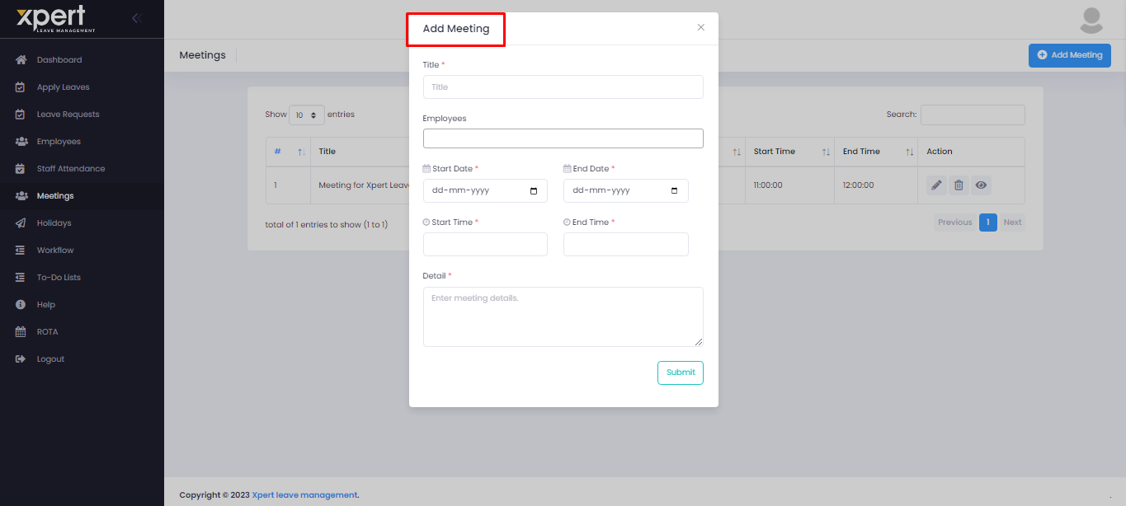

Employee Login:
Xpert Pro Features > Recent Activity (Xpert Pro):

Here you can view work from home and days-off events along with scheduled meetings in calendar.
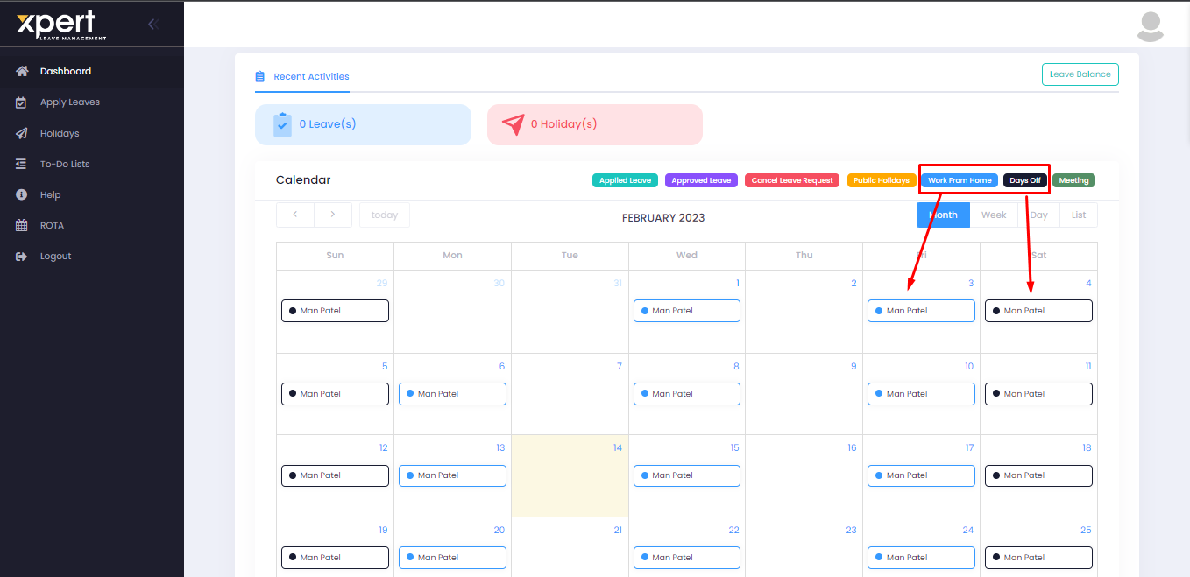

Profile View (Xpert Pro):
If it is pro account, then Employee can view Work from Home and Days off in their profile

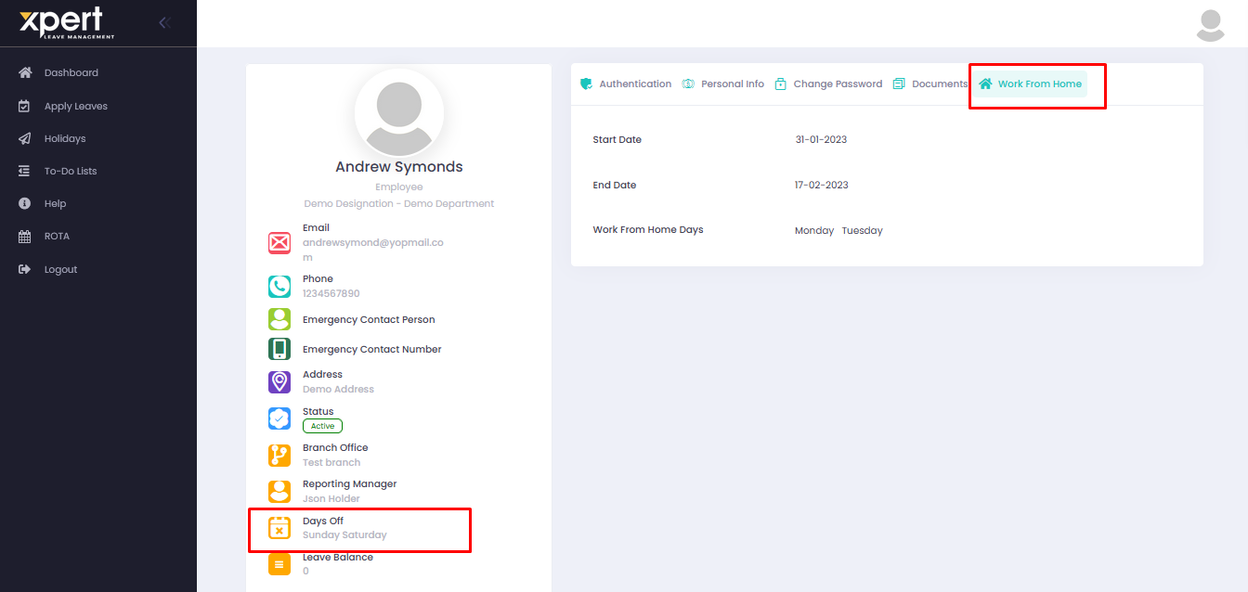

ROTA
View
If it is pro account, then employee can see ROTA in their dashboard
