1. Tags > Leads/Clients (documents tab): it is not working for private/global tags accordingly.
2. Profile picture for all logins. –done – Reopen – 1. Profile picture should get updated in all places where applicable.
3. Notifications /chat module notification auto update task pending.
4. Clients > Add/Edit: When change company with toggle on, it is not updating contacts (it should remove old company contacts).
5. In auto assigned email template related email, it is not showing first name & other tags in proper value. – Mail not received on email id. – again set emails for cron.
REA - Onboarding - In Progress (1 day)- VAT Records Request Email - S1 Employee
REA - Compliance - Records received (0 days) - Part Records Received Email - S1
REA - Custom - In Progress (1 day) - CS01 Confirmation Request Email - S1
REA - Test task - Waiting on Client (1 day) - Awaiting Approval Email - S1
REA - Previous Accountant - reopen11@yopmail.com - Email Template Testing (template)
6. phone number & email showing already exists but not added for that company yet – 654455666 - Discussion
7. It is not showing details when select secondary revenue. – Reopen – check with new account
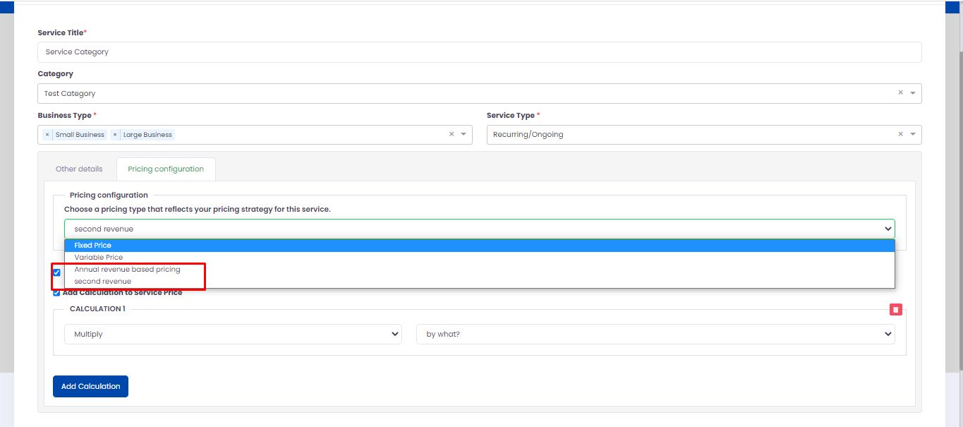
8. It is not showing guarantee’s letter tags dynamic .. check same for pdf & email both. – Reopen - Still reopen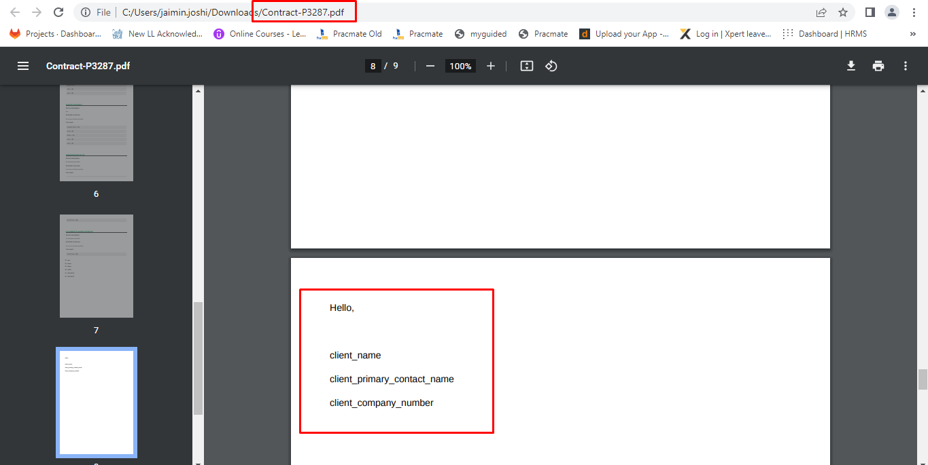

9. favourite folder – filter not working. – Pending from developer side
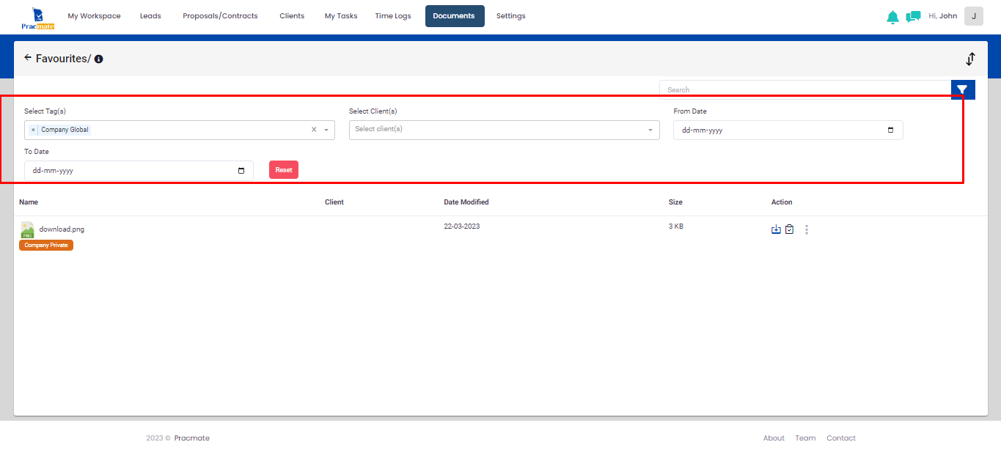
10. Email template values not showing dynamic. Check all email templates. – Reopen – still some of tags not showing with value.

